Country/Region/Global: Mozambique
Initiation Plan

Project Title: Stabilization and Recovery in Northern Mozambique

Expected UNDAF/CP Outcome(s):
- Outcome 2. Poor people benefit equitably from sustainable economic transformation
Outcome 8: All people benefit from democratic and transparent governance institutions and systems that guarantee peace consolidation, human rights and equitable service

Expected CPD Output(s):
- Output 1.1: National and subnational institutions enabled to enhance economic policy coherence and implementation
- Output 4.1. Mechanisms that promote a culture of peace and dialogue strengthened

Initiation Plan Start/End Dates: 21 June 2021 – 31 December 2022
Implementing Partner: UNDP

Brief Description
Cabo Delgado, one of the poorest provinces in Mozambique with the second largest commercially viable natural gas reserves in Africa, has been facing an escalating conflict since 2017, compounded by a fragile situation of chronic underdevelopment, consecutive climatic shocks, and recurrent disease outbreaks. Currently, over 900,000 people are facing severe hunger, including displaced persons as well as host communities, with over 1.3 million are in needs of urgent humanitarian support. As of May 2021, over 690,000 internally displaced people are partially located in relocation camps and informally hosted by already vulnerable communities across the Provinces of Cabo Delgado, Nampula, and Niassa.
The increase of violent attacks, the growing involvement of regional and international Non-State Actor Groups (NSAG), together with the structural nature of factors that have been identified as feeding into conflict dynamics in the northern provinces of Mozambique (Cabo Delgado, Nampula and Niassa), including chronic poverty, lack of services and infrastructure, unequal access to resources, lack of jobs and economic opportunities, disenfranchisement, remoteness, inequality, among others. Historical exclusion and marginalization suggests that the crisis is likely to continue into the medium term, if not worsen, and potentially expand in its geographic scope. The programme will be conceived and managed as an integrated area-based approach, combining on-going and future projects under one conceptual, programmatic and management umbrella. The Programme will be based on three interrelated and complementary dimensions including:
1) Stabilization: whereby the ability of individuals, communities, as well as institutions and systems affected by the crisis in Cabo Delgado, and more specifically in directly affected areas, is strengthened, and coping mechanisms supported, to manage the sudden increases in pressures and resist external shocks brought about by conflict, thus minimizing the negative impact of the crisis, and increasingly providing the security, stability and predictability required. Speed, scale and strengthening of the social contract will be key requisites for the stabilization programme.
2) Socio-economic recovery: whereby individuals, communities, as well as authorities, institutions and systems recover rapidly from conflict, thus paving the way for a more positive trend of socio-economic development and individual and collective prosperity.
3) Transformational change: whereby the dynamics influencing people’s lives in the northern provinces are fundamentally and systematically transformed, creating the conditions to accelerated peace and development, and preventing the recurrence of crises, in particular conflicts.

Total resources required $ 49,300,000
Total allocated resources: $ 5,410,587
TRAC 1 | 1,000,000.00
TRAC 2 | 1,900,587.00
RFF | 1,500,000.00
TRAC 3 | 100,000.00
SDPE | 660,000.00
FW_Rule of Law | 250,000.00
Total | 5,410,587.00
Unfunded budget: $43,889,413
In-kind Contributions $ 0

Programme Period: 18 months

Atlas Project Number: 00135796
Atlas Output ID: 00126947
Gender Marker: GEN 2

Agreed by UNDP: This Initiation Plan is created following the decision of the Crisis Board on the development and approval of the business case of UNDP Sub-Office in Pemba, Cabo Delgado. The PIP provides the arrangements for immediate implementation required to support the crisis response in the Province of Cabo Delgado in Mozambique.

Purpose and Expected Output
Cabo Delgado, one of the poorest provinces in Mozambique with the second largest commercially viable natural gas reserves in Africa, has been facing an escalating conflict since 2017, compounded by a fragile situation of chronic underdevelopment, consecutive climatic shocks, and recurrent disease outbreaks. Currently, over 900,000 people are facing severe hunger, including displaced persons as well as host communities, with over 1.3 million are in needs of urgent humanitarian support. As of May 2021, over 690,000 internally displaced people are partially located in relocation camps and informally hosted by already vulnerable communities across the Provinces of Cabo Delgado, Nampula, and Niassa.
The increase of violent attacks, the growing involvement of regional and international Non-State Actor Groups (NSAG), together with the structural nature of factors that have been identified as feeding into conflict dynamics in the northern provinces of Mozambique (Cabo Delgado, Nampula and Niassa), including chronic poverty, lack of services and infrastructure, unequal access to resources, lack of jobs and economic opportunities, disenfranchisement, remoteness, inequality, among others. Historical exclusion and marginalization suggests that the crisis is likely to continue into the medium term, if not worsen, and potentially expand in its geographic scope. Socio-economic grievances combined with recent natural disasters and violent attacks of non-State armed groups have exposed root causes of inequality in the province of Cabo Delgado as well as Nampula and Niassa in the north.
The current response to the displacement influx in the southern districts of Cabo Delgado and Nampula emphasises emergency relief – however, both humanitarian and Government partners recognise the need for longer-term durable solutions support to IDPs and recovery and development-oriented solutions for the population in Cabo Delgado as well as Nampula and Niassa provinces. Given its experience in crisis response, both in disaster and conflict contexts, and ability to deliver an integrated package of programme interventions, tailored to the context and needs, UNDP is well-placed to support stabilization, and recovery in northern Mozambique, including durable solutions for IDP, building the foundations for development.
This program initiation plan (PIP) proposes to implement a stabilization programme in the northern districts of Cabo Delgado while expanding recovery and development interventions in the most accessible areas in the provinces of Cabo Delgado, Nampula and Niassa. The vision of UNDP Mozambique is to support the people of the northern provinces of Mozambique to achieve peaceful coexistence, recover from the crisis and free themselves from extreme poverty and exclusion. Hence, UNDP aims to lead stabilization, recovery, and long-term development effort of the international community, supporting development solutions for displacement and for all communities in the North of Mozambique, complementing efforts of the humanitarian partners where relevant, and strengthening community resilience against conflict and climate-related shocks. UNDP’s will ensure a conflict-sensitive, do no harm, rights-based and gender-sensitive approach through its response.
The programme will be conceived and managed as an integrated area-based approach, combining on-going and future projects under one conceptual, programmatic and management umbrella. The Programme will be based on three interrelated and complementary dimensions including:
1) Stabilization: whereby the ability of individuals, communities, as well as institutions and systems affected by the crisis in Cabo Delgado, and more specifically in directly affected areas, is strengthened, and coping mechanisms supported, to manage the sudden increases in pressures and resist external shocks brought about by conflict, thus minimizing the negative impact of the crisis, and increasingly providing the security, stability and predictability required. Speed, scale and strengthening of the social contract will be key requisites for the stabilization programme. Key activities will include:
1.1) rehabilitation of public, security, and social infrastructure damaged by conflict (e.g. administrative functions, police services, prisons, schools, health centers/post, water systems,)
1.2) temporary employment opportunities using Cash for Work through community projects promoting social cohesion / integration benefiting population (e.g. improvement of streets and roads, local parks, sports areas, cultural sites)
1.3) support to community security and violence reduction (e.g. material support, training on human rights, GBV)
2) Insitutitional building: Regional, Provincial and local institutions, mechanisms and sytems strengthened
Institutional capacities and mechanisms strengthened for planning and provision of local basic services and infrastructure, as well as crisis response and management. This area of focus includes including Institutional Mechanisms and Capacities for Local Socio-Economic Recovery and Development including Durable Solutions for IDPs. UNDP will support the capacities of key Government institutions at the Regional, Provincial and Local level to provide services to its citizens and enhance the social contract. Interventions envisioned include:
2.1) Support the Agency for the Integrated Development in the North (ADIN) by strengthening its coordination and planning capacity for the Northern Provinces and the data analysis and monitoring systems
2.2) Support an effective functioning of Provincial Coordination Councils to facilitate horizontal and vertical intergovernmental relations
2.3) Support will also be provided in identifying Local Economic Development Opportunities, including economic opportunity assessments, identifying comprehensive opportunities for value-chain development in the Northern provinces and entry points for support for local SMEs and strengthening the capacities of the Business Associations and Networks
3) Socio-economic recovery: whereby individuals, communities, as well as authorities, institutions and systems recover rapidly from conflict, thus paving the way for a more positive trend of socio-economic development and individual and collective prosperity.
3.1) rehabilitation of public and social infrastructure damaged by conflict (e.g. schools, health centers/post, water systems, administrative functions)
3.2) support to temporary employment opportunities using 3x6 approach to promote economic activity and business creation
3.3) identification of small projects to promote social cohesion and peaceful coexistence
4) Peacebuilding and Access to Justice (Transformational change): whereby the dynamics influencing people’s lives in the northern provinces are fundamentally and systematically transformed, creating the conditions to accelerated peace and development, and preventing the recurrence of crises, in particular conflicts.
4.1) Support to peace dialogue
4.2) Support/create district platforms for community resolution and mediation led and managed by women
4.3) Promote access to justice (documentation, mobile courts)
The PIP will also support the establishment of a sub-office in Pemba, Cabo Delgado for the full multi-year programme on Stabilization, Recovery & Transformation in North of Mozambique. The sub-office will operate with strong coordination and support from the Maputo office and programmatic support from UNDP Project Office in Beira. This component includes:
5) Management support and coordination
5.1) Establish sub-office in Pemba
5.2) Systems in place for operational support to programmatic activities (e.g. establish petty cash, bank accounts, appropriate levels of delegation of authority)
5.3) Recruitment of operational and program staff
The approach is based on UNDP’s experience in addressing multidimensional crises through community stabilization programmes that provide comprehensive crisis response and build the foundation for recovery and development, simultaneously targeting institutional capacity building and generation of peace dividends through integrated socio-economic recovery interventions with investment in peacebuilding and longer-term development.
The programme in Northern Mozambique will apply a two-phased, staggered approach, which will be flexible and adaptive to the changing conditions and local contexts, but with core principles observed: a first phase (first six months) focusing on supporting IDPs and hosting communities, in currently accessible areas in Cabo Delgado, Nampula and Niassa, both in urban and rural areas, with added focus on supporting the response to the influx of IDPs; at the same time the Programme will concurrently start stabilization in the northern districts most affected by the conflict followed by a longer-term recovery and development response, prioritizing areas affected by displacement, as part of an overall regional development efforts in the North of Mozambique.
UNDP’s Integrated Area-Based Development Programme and Policy Offer is initially estimated to require US$49.3 million for the 18-month period. Under this PIP, UNDP has already mobilized approximately US$ 10 million to kick-start implementation of the programme. In the immediate time, UNDP is allocating 5,410,587 as per work plan below while preparing the reallocation of the remaining available resources and mobilizing additional resources. The work plan will be updated and documented accordingly.
To achieve the aforementioned program for northern Mozambique, UNDP Mozambique has presented this Program Initiation Plan (PIP) as described below in the Workplan (see Section IV). Key activities include the procurement of equipment and civil works to improve basic social services, the creation of temporary employment opportunities, research and analysis and creation of forums for peaceful dialogue and access to justice.

Management Arrangements
The programme for northern Mozambique will fall under the direct responsibility of the Head of Sub Office (HoS-O)in Pemba. S/he will be have delegation of authority to ensure compliance with UNDP procedures, policies, and processes. The HoS-O will be the main representative of UNDP in the geographic zone, in charge of liaison with counterparts, support to inter-agency coordination in the sub-area, and functions and operations of the sub office. The HoS-O is responsible for overall programme coordination at the SO level, supervises project management based on Quarterly Work Plans approved by the Project Board, and ensures coordination across projects in the sub-area.

The Head of Sub-Office will be supported by an Operations Manager who will be responsible for finance, logistics, procurement, security of the sub-office. A senior programme Advisor for Livelihoods and Recovery Specialist (SLRS) will provide overall leadership and will be responsible for developing the detailed programmatic approach in coordination with the HoS-O, the DRR, and RR. The SLRS will play a key role in the positioning of UNDP in livelihoods, recovery and the practical conceptualization and implementation of the Humanitarian-Development-Peace Nexus (HDP Nexus). In addition, the SLRS will:

1) Support the elaboration of a Durable solutions Strategy for Displacement.
2) Ensure that relevant interventions and activities to enhance gender-responsiveness are mainstreamed, with relevant projects developed for WEE and GBV.
3) Responsible for the coaching of the national core team in teams of UNDP’s approach in the assigned area.
4) Support the launch of UNDP’s activities in the ground.
5) Effectively build partnerships with stakeholders, partners, and donors in expertise area.

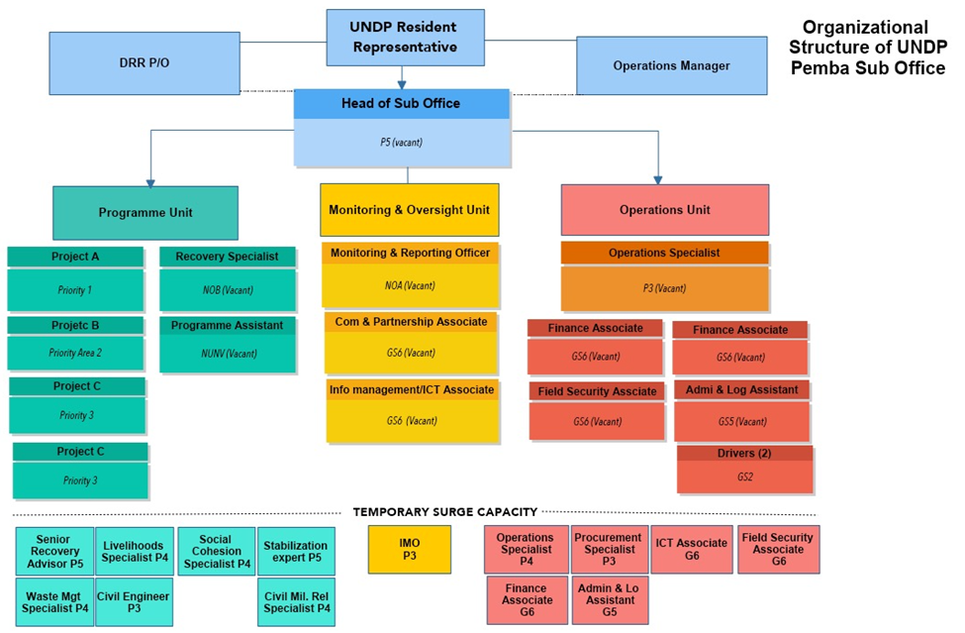

Monitoring
A combination of monitoring tools and mechanisms will be applied to track results progress on a quarterly basis. Progress data against the results indicators in the log frame will be collected and analysed to assess the progress of the project in achieving the agreed outputs. A risk matrix will be developed identifying risks and mitigation actions (see following page). Risk will be assessed and updated on a quarterly basis. Through quarterly implementation meetings challenges to implementation will be identified and corrective measures developed to ensure effective and efficient delivery. The meetings will be documented and good practice identified. The sub-office will seek collaboration from Maputo office to develop knowledge products based on experience from implementation.
An annual report will be produced and progress / experience integrated into UNDP Mozambique ROAR process.

Risk Management and Mitigation Plan
Risk Category | Risk Description | Rating | Mitigation Strategy
Safety and Security | Deterioration of the security situation in the north | High | Frequent monitoring of the situation, review of the implementation timeline, applying appropriate security measures for staff and partners.
Safety and Security | Access to communities, is restricted or disrupted | High | Head of Sub-Office will participate in Area Security Management Team meetings  UNDP staff and contractors strictly abide by UNDSS security arrangements and agreements with the Government of Mozambique.
Safety and Security | Unwillingness of youth and women to participate in activities due to perceived exposure or fear of becoming target of violent/armed groups | Medium | Establishing communication channels at community level to enhance trust and understanding about the project objectives; avoid sensitive language that may cause harm or negative misperception from the community;  Ensuring safe spaces and enabling environment for participants, in particular women;  Creating spaces (communication platforms) where young people can cooperate with authorities and their voice can be heard
Programmatic | Low capacity of local partners to implement and support project activities | Medium | Supporting local partners in planning, implementation, on-job support.
Health | Spread of COVID-19 pandemic in targeted areas of the project | Medium | Adaptive management to ensure activities are implemented and aligned with national measures in place to respond to COVID-19 and ensure safety and security of participants.
Environmental | Occurrence of high impact natural disaster(s) | Medium | Assessing the effect on targeted communities and government priority shifting and adjusting implementation .
Programme | Implementing partners/contractors are or feel threatened by violent/armed groups | Medium | Assessing contextual conditions for implementation to ensure safe spaces and enabling environment for participants are provided based on UN and government’s security guidance.
Financial | Fluctuation of local currency and US dollar may affect cost of implementation | Medium | Monitoring exchange rate and assessing impact for programme delivery.

WORK PLAN

Period:

EXPECTED OUTPUTS  And baseline, indicators including annual targets | PLANNED ACTIVITIES  List activity results and associated actions | TIMEFRAME |  |  |  |  |  | RESPONSIBLE PARTY | PLANNED BUDGET
 |  | Q1 | Q2 | Q3 | Q4 | Q5 | Q6 |  | Funding Source | Budget Description | Amount
Output 1 - Stabilization and Recovery enhanced in Cabo Delgado (PIP)  Related CP outcome:  Output 4.1  Output 1.1  Number of public facilities rehabilitated  Baseline: 0  Target: 45  Number of people benefitting from cash for work  Baseline: 0  Target: 3,000  Number of small business supported  Baseline: 0  Target: 45  Number of institutions receiving capacity building support  Baseline: 0  Target: 17  Sub-Office established  Baseline: staff partially onboard; no operational office space.  Target: planned staff fully onboard as per the business case; operational office space. | Activity 01 - Stabilization  Stabilization in the 6 Northern Districts most directly affected by violence (Macomia, Mocimboa da Praia, Quissanga, Nangade, Muidumbe and Palma)  - Field visits  - Infrastructure  - cash-forwork/temporary employment  - Social cohesion/rule of law | X | X | X | X | X | X | UNDP | TRAC1  TRAC 3 |  | 1,000,000  50,000
 | Activity 2 - Insitutitional building  Regional, Provincial and local institutions, mechanisms and sytems strengthened  - Research and analysis  - Infrastructure  - Equipment  - Capacity building |  | X | X | X | X | X | UNDP | TRAC 2  SDPE 28200  Rrf covid (04001) |  | 1,400,587  660,000  750,000
 | Acitvity 3 - Economic recovery and development  - Research and analysis  - Cash for work  - Enterprise support  - Private sector development  - Economic infrastructure support | X | X | X | X | X | X | UNDP | Rrf Covid (04001) |  | 750,000
 | Acitvity 4 - Peacebuilding and access to justice  - Research and analysis  - Legal aid  - Support to community courts  - Cross-border dialogue  - Community security | X | X | X | X | X | X | UNDP | 28623 (FW_Rule of Law)  TRAC 2 |  | 250,000  500,000
 | Activity 5 - Management and coordination  - Field visits  - Staffing and Travel  - Security  - Sub office setup  - Sub office running costs | X | X | X | X | X | X | UNDP | TRAC 3 |  | 50,000
TOTAL |  |  |  |  |  |  |  |  |  |  | 5,410,587

Maximum 18 months

